**Rules for Cowichan Lake**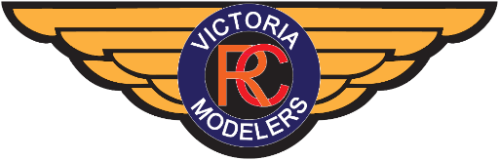

**General:**

-Everyone must **abide by** [**Canadian Aviation Regulations (CARs) Part IX**](https://lois-laws.justice.gc.ca/eng/regulations/SOR-96-433/FullText.html#s-900.01)**:**

-For RPAS between 250g and 25kg:

-A valid Basic Pilot Certificate (and Proof of Recency) is required.

-RPAS Certificate of Registration, with the number marked on the RPA(s).

-Documents are required with the Pilot: RPAS Certificate, Recency (if required), Flight Logbook, Maintenance Logbook, Instruction Manual.

-Completed Site Survey (via RPAS Wilco)

**It is incumbent on the pilot to maintain compliance to CAR Part IX.**

[You could face serious penalties, including fines and/or jail time, if you break the rules.](https://tc.canada.ca/en/aviation/drone-safety/learn-rules-you-fly-your-drone/flying-your-drone-safely-legally)

-In addition to CAR Part IX, everyone must **abide by all MAAC Safety Codes and Policies**.

-A current paid **membership with MAAC is mandatory** to fly.

-If there is an **incident it must be immediately reported to the first person available** as follows:

-Chief Safety Officer: Stan Anderson 250-598-7566

-President: Wayne Powell 250-507-2554

-Vice President: Chris Munson 778-700-2160

-Secretary: Stewart Harding 250-818-5127

-Treasurer: Duncan Ferguson 778-677-3494

-Director at Large: Klaus Moser 250-595-7496

-Chief Flight Instructor: Paul Nazaroff 250-497-6321

**Flying:**

-A **maximum of four (4) aircraft** are permitted to be in the air at the same time.

-Pilots must **not fly, take off, or land their aircraft behind the Flight Line or outside the Flying Area** (see map below). This is a hard limit! Only taxiing is permitted between the Flight Line and the shoreline.

-When **people are in the flying area, a spotter is mandatory** and the spotter must be able to communicate effectively with all pilots actively flying.

-**All pilots must yield the right of way to people and person-carrying watercraft.** If flying, 100m lateral clearance is required. Do not fly such that the person is directly between the pilot and their aircraft.

**-Immediately avoid and land in the presence of general aviation.**

-**A means of retrieval** (e.g., boat, kayak, etc.) **must be available at all times** to retrieve aircraft unable to return to shore under their own power.

-**Pilots should announce their intention** to take off, the direction they're taking off to, landing, touch-n-gos, etc. and all other pilots should acknowledge the announcement.

-**Takeoffs and landings** shall be executed **with the prevailing traffic pattern**. Changes in the direction should occur only when all aircraft have landed and all pilots have been informed.

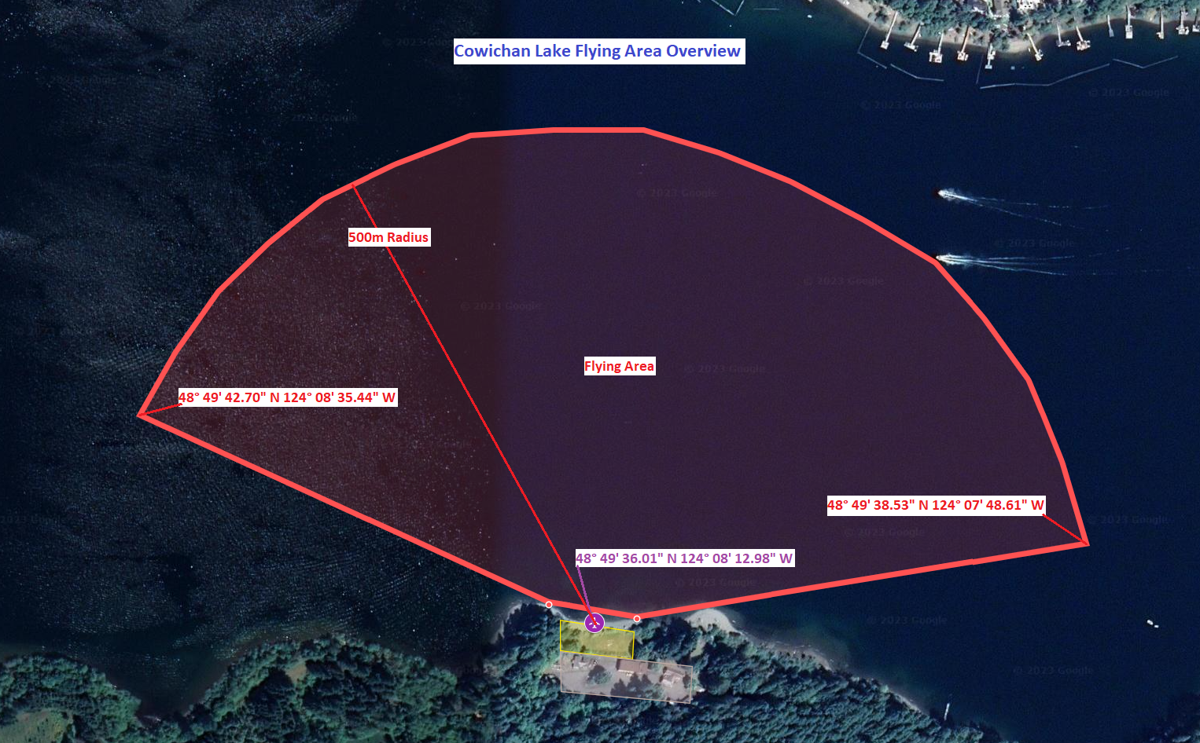

-The **Flying Area** is within 500m of the Pilots Stations, with direct line of sight over water (no flying over land allowed)

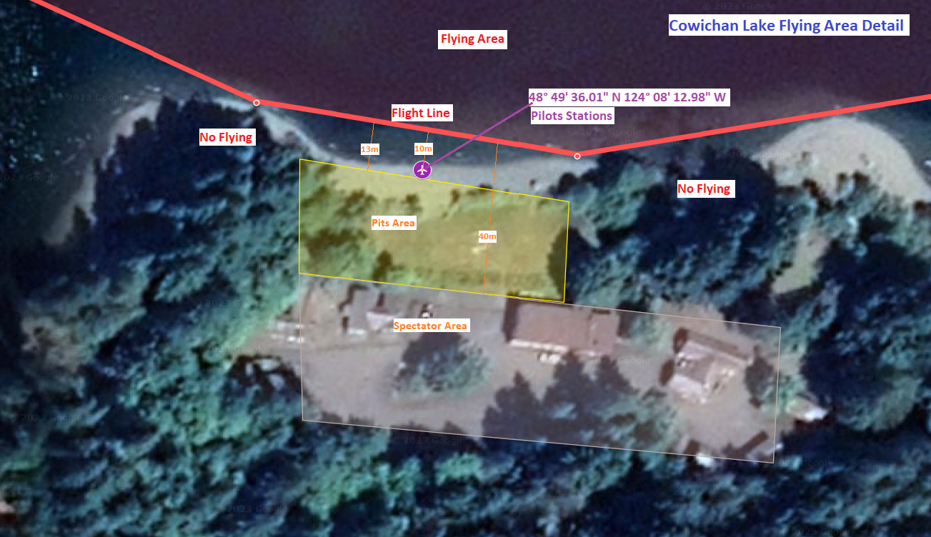

-The **Flight Line** is a straight line between the East and West points at the ends of the bay.